Tab 1
UNIVERSITY OF HULL
FACULTY OF SCIENCE AND ENGINEERING

CENTER OF EXCELLENCE FOR DATA SCIENCE, ARTIFICIAL INTELLIGENCE AND MODELLING

Job Dissatisfaction in the UK: A Multi-Year Social Media Analysis Using Sentiment Analysis and Topic Modelling (2020-2025)

BY

STUDENT NAME: AWOPETU RASHEED OLUWADAMILARE
STUDENT NUMBER: 202432121
PROJECT SUPERVISOR: DR. CLAIRE CASHMORE

A PROJECT SUBMITTED IN PARTIAL FULFILLMENT OF THE REQUIREMENTS FOR THE DEGREE OF MASTER OF ARTIFICIAL INTELLIGENCE AND DATA SCIENCE

JANUARY, 2026

DEDICATION
I dedicate this dissertation to my late father, whose unwavering support and belief in my potential continue to guide my journey. Your wisdom and love remain with me and this accomplishment is in honour of all that you gave me.

ACKNOWLEDGEMENTS
I would like to express my deepest gratitude to everyone who supported me throughout the journey of completing this dissertation.
First and foremost, I thank God for strength, guidance and the perseverance to reach this stage.
I am profoundly grateful to my supervisor, Dr. Claire Cashmore, whose guidance, patience and constructive feedback were invaluable at every stage of this research. Your support challenged me to think critically and helped shape this work into what it is today.
I extend my heartfelt appreciation to my family for their unwavering encouragement, love and belief in my abilities. To my late father, whose memory continues to inspire and motivate me, you remain a source of strength in everything I do. To my mother and my sister, thank you for your constant support, understanding and encouragement throughout this journey. Your love and reassurance kept me grounded and motivated.
I am also thankful to my friends and colleagues, who offered encouragement, helpful discussions and moments of balance when the work became overwhelming. Your presence made this process lighter and more meaningful.
Finally, I acknowledge the communities whose shared experiences on Reddit formed the basis of this study. Their willingness to voice their workplace challenges made this research possible.
To everyone who contributed in ways big and small
Thank you.

ABSTRACT
Job dissatisfaction has become a persistent and multifaceted challenge in the United Kingdom, intensified by socio-economic disruptions such as the COVID-19 pandemic, the expansion of remote work and the ongoing cost-of-living crisis. While traditional labour market surveys capture broad trends, they often miss the emotional nuance and lived experience of workers. This study addresses this gap by analysing large-scale, unstructured social media data to examine how job dissatisfaction was expressed by UK Reddit users between 2020 and 2025.
Data were collected from ten UK-relevant subreddits using the PRAW API and the Eye.eu Reddit archive. A multi-method Natural Language Processing (NLP) framework was applied, integrating lexicon-based (VADER, TextBlob) and transformer-based sentiment analysis with supervised classification using Naive Bayes, Support Vector Machines, Convolutional Neural Networks and a BERT-based model. Topic modelling was conducted using Latent Dirichlet Allocation (LDA) and BERTopic to identify dominant and evolving themes over time.
The findings reveal substantial divergence across analytical methods, with lexicon-based tools producing more positive-skewed outputs and transformer models identifying predominantly neutral sentiment, reflecting the narrative and reflective style of worker complaints. Supervised classification confirms the superior performance of contextual transformer models, while topic modelling shows a shift from crisis-driven concerns such as public health pressures and job insecurity (2020-2022) toward political, institutional and wellbeing-related dissatisfaction by 2025.
Overall, the study demonstrates that UK job dissatisfaction has transitioned from an acute crisis response to a chronic condition embedded in everyday working life. Methodologically, it underscores the value of triangulating sentiment and topic-modelling approaches when analysing complex social-media discourse, offering both substantive insight into contemporary work dissatisfaction and guidance for future computational social science research.

LIST OF FIGURES
- Figure 1: Grouped Bar Chart of vader sentiment per year
- Figure 2: Grouped Bar Chart of Text Blob sentiment per year
- Figure 3: Grouped Bar Chart of Transformer-based sentiment per year
- Figure 4: Average Confidence Levels of Sentiment Models
- Figure 5: Naive Bayes Trends (2020-2025)
- Figure 6: SVM Trends (2020-2025)
- Figure 7: CNN Trends (2020-2025)
- Figure 8: Transformer-Bert Trends (2020-2025)
- Figure 9: Best Model VS Best Labelling per year Based on f1 Score (2020-2025)

LIST OF TABLES
- Table 1: Comparison of Data Sources Used for Reddit Collection (2020-2025)
- Table 2: Amount of Data Collected per Year (2020-2025)
- Table 3: Comparison of Sentiment-Labelling Methods Used in the Study
- Table 4: Comparison of Machine Learning Models
- Table 5: Comparison of Topic-Modelling Methods Used in the Study
- Table 6: Inter-Model Agreement (Cohen’s Kappa, 2020-2025)
- Table 7: Dominant LDA Topic per Year (2020-2025)
- Table 8: Dominant Bertopic Topic per Year (2020-2025)
- Table 9: Thematic Analysis Topic per Year (2020-2025)

TABLE OF CONTENTS
TITLE PAGE i
DEDICATION ii
ACKNOWLEDGEMENTS iii
ABSTRACT iv
LIST OF FIGURES v
LIST OF TABLES vi
TABLE OF CONTENTS vii
1.0 INTRODUCTION 1
1.1 Background and Motivation 1
1.2 Related Work 2
1.3 Research Gap and Purpose of the Study 3
1.4 Research Aims and Objectives 4
2.0 METHODOLOGY 4
2.1 Data Collection And Pre Processing 4
2.2 Sentiment Labelling Methods 7
2.3 Machine Learning Models 8
2.4 Topic modelling 10
3.0 RESULT 11
3.1 Sentiment Distribution Across Years (2020-2025) 11
3.1.1 VADER Sentiment Trends (2020-2025) 12
3.1.2 Text Blob Sentiment Trends (2020-2025) 12
3.1.3 Transformer Sentiment Trends (2020-2025) 13
3.1.4 Average Confidence Levels of Sentiment Models (2020-2025) 14
3.1.5 Inter-Model Agreement (Cohen’s Kappa, 2020-2025) 14
3.2 Machine Learning Classification Results (2020-2025) 15
3.2.1 Naive Bayes Trends (2020-2025) 15
3.2.2 SVM Trends (2020-2025) 16
3.2.3 CNN Trends (2020-2025) 17
3.2.4 Transformer(Bert) Trends (2020-2025) 18
3.2.5 Best Model Vs Best Labelling (Sentiment) (2020-2025) 18
3.3 Topic Modelling Trend Across Years (2020-2025) 19
3.3.1 LDA (Latent Dirichlet Allocation) Trend across Years (2020-2025) 19
3.3.2 Bertopic Trend across Years (2020-2025) 20
3.4 Thematic Analysis Trend Across Years (2020-2025) 22
3.5 Temporal Analysis Trend Across Years (2020-2025) 23
4.0 DISCUSSION 23
5.0 CONCLUSION 25
REFERENCES 27

1.0 INTRODUCTION

1.1 Background and Motivation
Job dissatisfaction has emerged as a significant and persistent challenge within the United Kingdom, particularly since the COVID-19 pandemic disrupted labour markets and reshaped working practices. Recent evidence suggests that problems with job quality have not only endured but intensified. The latest CIPD Good Work Index (2024) reports that one quarter of UK employees experienced workplace conflict in the previous year, including being undermined, shouted at or subjected to verbal abuse experiences associated with heightened exhaustion, poorer wellbeing and increased psychological strain. According to the CIPD Good Work Index (2024), attitudes toward work have also shifted: 47% of workers now view their job as “just about the money,” up from 36% in 2019 and discretionary effort has declined. These findings align with structural pressures documented by the Office for National Statistics (ONS, 2022), including rising unpaid overtime, persistent low pay and regional inequalities in progression. A UK Parliament POSTbrief (2022) further highlights how the expansion of remote and hybrid work introduced new complexities, blurring work-life boundaries and contributing to burnout. Together, these datasets suggest that job dissatisfaction is multi-dimensional, evolving over time and influenced by wider economic and social disruptions. Conventional labour-market surveys often capture only structured, periodic snapshots, which may overlook the nuanced emotional experiences of day-to-day working life. In contrast, social media platforms, particularly Reddit, provide rich, unfiltered narratives revealing workers’ frustrations, concerns and lived realities. Subreddits such as r/UKJobs, r/antiwork, r/recruitinghell and r/WorkReformUK host candid discussions on managerial behaviour, workload pressures, burnout and organisational cultures. Reddit’s anonymity reduces fear of professional repercussions, encouraging open disclosure and making the platform a valuable but under-examined data source for understanding dissatisfaction in contemporary UK workplaces. The scale and unstructured nature of Reddit data necessitate the use of Natural Language Processing (NLP). Sentiment analysis can uncover emotional tone, while topic modelling identifies the drivers of dissatisfaction, such as low pay, toxic environments or poor management practices. Advancements in NLP have improved capacity to analyse such data: lexicon-based tools like VADER (Hutto & Gilbert, 2014) offer interpretability and perform well on informal text but struggle with sarcasm and context; transformer-based models (e.g., BERT; Devlin et al., 2019) capture contextual nuance more effectively but require greater computational resources. Similar methodological trade-offs exist in topic modelling: classical approaches such as LDA (Blei et al., 2003) are well established but often produce incoherent themes in short posts, whereas embedding-based methods like BERTopic (Grootendorst, 2022) yield more coherent topics but depend heavily on embedding quality. These methodological tensions create an important space for critical comparison within work-related discourse.

1.2 Related Work
Traditional research on job dissatisfaction highlights organisational, psychological and economic factors. Classic studies such as Spector (1997) and Clark (2005) link dissatisfaction to low pay, limited support and poor working conditions. More recent evidence reflects post-pandemic shifts. Florisson (2024) reports rising job-quality concerns, with high levels of exhaustion, excessive pressure and heavy workloads, while only 41% of workers feel inspired at work. Eurofound (2023) similarly identifies declining autonomy, intensifying work demands and increasing digital monitoring as key contributors. Despite these developments, most evidence still relies on structured surveys, which do not capture the spontaneous, emotionally expressive ways dissatisfaction now appears in online environments.
As scholars seek to understand work experiences in more dynamic ways, social media has gained prominence as an alternative data source. Reddit, in particular, has been recognised for its suitability for text-based research due to its topic-specific communities, comment threading and strong culture of anonymity. Curiskis et al. (2020) show that embedding-based models particularly Word2Vec and Doc2Vec outperform classical approaches such as TF-IDF, NMF and LDA when applied to Reddit’s short, informal posts, though their study remains methodological rather than domain-specific. Melton et al. (2021) show how Reddit discussions can track public attitudes over time, using TextBlob for sentiment analysis and LDA topic modelling to examine COVID-19 vaccine discourse. Their findings illustrate social media’s value for studying socio-behavioural phenomena but do not address employment-related issues.
Research focused explicitly on work-related topics remains limited. Garg, Kapadia and Sengupta (2021) identify heightened expressions of anxiety and frustration within US unemployment-related subreddits, yet the study is narrow in scope and lacks relevance to broader UK labour conditions. Earlier work by Weninger, Zhu and Han (2013) highlights how Reddit’s linguistic characteristics such as sarcasm, humour and informal tone can complicate sentiment interpretation and require careful methodological consideration. These issues are especially relevant when analysing emotionally charged topics such as job dissatisfaction.
NLP tools used in such research each come with trade-offs. VADER, though widely used due to its effectiveness on microblogging platforms, often misinterprets complex rhetorical devices like irony, which are common in Reddit discussions. LDA continues to be applied in many studies but frequently struggles with semantic coherence in short texts. More recent approaches such as BERTopic have shown promise, with Egger and Yu (2022) finding it superior to LDA, NMF and Top2Vec for generating coherent topics from online content. Despite these methodological insights, no study to date has systematically evaluated these tools within the specific context of UK job dissatisfaction, leaving both an empirical and methodological gap.

1.3 Research Gap and Purpose of the Study
The existing literature points to several important gaps. First, research examining UK job dissatisfaction through organic social media discourse is extremely limited, despite evidence that online platforms capture emotional and experiential dimensions often absent from traditional surveys. Second, no study has conducted a multi-year analysis of UK worker sentiment across key socio-economic disruptions, including the COVID-19 pandemic and the cost-of-living crisis. Third, there is little systematic comparison of sentiment analysis and topic modelling techniques within this domain, despite known methodological tensions and performance differences across tools. Finally, the influence of data collection methods themselves, for example, variation between Reddit’s PRAW API and third-party archives like Eye.eu has received minimal scrutiny, even though such differences may introduce sampling biases and affect analytical outcomes.
This study addresses these gaps by conducting the first six-year, UK-focused analysis of job dissatisfaction on Reddit (2020-2025) while critically evaluating how methodological choices shape interpretations of workers’ experiences.

1.4 Research Aims and Objectives
The overall aim of this dissertation is to investigate how job dissatisfaction is expressed by UK workers on Reddit between 2020 and 2025 and to evaluate how methodological choices influence the interpretation of this discourse. Using multi-year social media data, the study combines sentiment analysis, supervised classification and topic modelling to provide both substantive and methodological insight.
The study pursues four objectives. First, it conducts a systematic comparison of sentiment analysis tools (VADER, TextBlob and a transformer-based classifier) and topic modelling approaches (LDA and BERTopic), assessing their suitability for Reddit’s informal and context-rich text. Second, it examines how expressions of job dissatisfaction evolve over time in relation to major socio-economic events, including the COVID-19 pandemic and the cost-of-living crisis. Third, it identifies key themes underpinning dissatisfaction, such as pay, workplace stress, management practices, mental health and work-life balance. Finally, it evaluates how different Reddit data collection methods (PRAW API and Eye.eu archive) affect dataset composition, coverage and representativeness.

2.0 METHODOLOGY

2.1 Data Collection And Pre Processing
This study investigates job dissatisfaction in the United Kingdom by analysing Reddit posts published between 2020 and 2025, a period characterised by the COVID-19 pandemic, the widespread adoption of remote work and rising living costs. These socio-economic pressures shaped workers’ experiences and made this timeframe valuable for examining shifts in workplace sentiment.
Data collection employed two complementary sources: the PRAW API and the eye.eu Reddit archive. PRAW, Reddit’s official Python API wrapper, retrieved posts and comments from 2023-2025, providing reliable access to recent content but limited historical depth due to API restrictions. Earlier data from 2020-2022 was collected using eye.eu, which provides a publicly accessible version of the Pushshift archive but contains no material beyond 2022. Using both tools ensured complete temporal coverage and allowed each to be used during the period where it performs most effectively.
CRITERIA | PRAW API | EYE.EU/ Pushshift Archive
Years Used | 2023-2025 | 2020-2022
Type of Access | Live API access (recent posts) | Historical archive
Data Availability | Cannot retrieve pre-2022 data | No data beyond 2022
Strengths | Accurate, up-to-date content; direct from Reddit | Fast bulk retrieval; extensive historical coverage
Limitations | Rate limits; limited historical depth | Occasional missing posts; dependent on archival completeness
Reason for Use | To capture the most recent years of the dataset | To obtain earlier years that the API cannot access
Table 1: Comparison of Data Sources Used for Reddit Collection (2020-2025)
All retrieved data was publicly available and anonymised with no personal or identifying information collected. Data handling complied with Reddit’s API Terms of Service and institutional ethical guidelines. For PRAW access, authentication credentials were securely stored in a .env file to protect login details. All posts and comments matching the filtering criteria were included rather than sampled.
Ten subreddits were selected for their strong relevance to UK employment and workplace discourse. r/UKJobs, r/careerguidance, r/AskHR and r/recruitinghell provide direct discussions on job searching, workplace challenges and career issues. r/AskUK, r/CasualUK, r/unitedkingdom and r/britishproblems capture broader UK social conversations where users frequently raise work-related concerns. r/antiwork, r/WorkReform and r/WorkReformUK focus on labour dissatisfaction and organizational issues, contributing insights into systemic workplace problems.
To avoid sentiment bias, posts were extracted using both dissatisfaction-related keywords (e.g., “burnout,” “toxic workplace,” “underpaid”) and satisfaction-related keywords (e.g., “happy at work,” “supportive manager”). UK relevance was enforced using a regular expression filter matching terms such as “United Kingdom,” the four UK nations and major cities.
Posts and comments were saved as yearly CSV files and later merged into unified annual datasets. Table 2 summarises the dataset size collected per year.
Year | Number of Posts | Number of Comments | Total Retrieved | Final Cleaned Dataset | Data Source
2025 (January 2025 -> November 23) | 5,498 | 62,452 | 67,950 | 66,684 | PRAW API
2024 | 2,473 | 28,675 | 31,148 | 30,296 | PRAW API
2023 | 1,620 | 21,014 | 22,634 | 21,878 | PRAW API
2022 | 996 | 36,138 | 37,134 | 36,040 | EYE.EU
2021 | 589 | 21,336 | 21,925 | 21,294 | EYE.EU
2020 | 317 | 13,197 | 13,514 | 13,171 | EYE.EU

Table 2: Amount of Data Collected per Year (2020-2025)

The merged datasets underwent a structured preprocessing pipeline. Only posts with meaningful text were retained, while duplicates, deleted entries and empty rows were removed. Standard cleaning eliminated URLs, emojis, hashtags, punctuation and other non-linguistic features. The author column was dropped due to Reddit’s anonymity. Stopword removal and lemmatisation refined linguistic structure, ensuring high-quality input for traditional machine-learning and transformer-based models. All preprocessing was conducted using Python, PRAW, pandas, regex and NLTK and applied consistently across all years.
Although the dataset offers rich insight into UK workplace experiences, limitations remain. Pushshift may contain historical gaps and PRAW’s access constraints may affect completeness. Reddit users also differ from the wider UK workforce. These factors should be considered when interpreting generalisability.
The cleaned dataset, stored as CSV, supported sentiment labelling and subsequent modelling, including machine-learning classification and topic modelling with LDA and BERTopic.
All stages of the pipeline including data collection, preprocessing, sentiment labelling, machine-learning classification and topic modelling were carried out separately for each year with annual datasets processed and analysed independently.

2.2 Sentiment Labelling Methods
Sentiment analysis was a core component of this study, providing labels for training machine-learning models to classify job-related emotional expression. To improve reliability and interpretability, three sentiment-labelling approaches were used: VADER, TextBlob (Loria, S., 2018) and a transformer-based classifier, the Reddit Sentiment Analysis Longformer (Spacesedan, n.d). Using multiple methods allowed comparison between lexicon-based and contextual transformer approaches, reducing reliance on a single model.
VADER and TextBlob are lexicon-based tools that assign sentiment by matching words to predefined sentiment dictionaries. VADER generates positive, neutral, negative and compound scores, with the compound value (-1 to +1) converted into sentiment categories using standard thresholds. Its handling of negation, punctuation and intensity modifiers makes it suitable for informal Reddit language. TextBlob produces polarity and subjectivity scores; polarity was used for sentiment classification, while subjectivity provided insight into whether posts reflected opinion or factual content. However, both tools can struggle with sarcasm and context-dependent language.
To address these limitations, a transformer-based Longformer model fine-tuned for Reddit data was applied. It performs five-class sentiment classification, capturing more nuanced emotional intensity. Combining lexicon-based and transformer methods strengthened sentiment labelling and enabled evaluation of their impact on downstream modelling.
Method | Outputs | Thresholds / Ranges | Strengths | Limitations
Vader | Positive, Neutral, Negative, Compound (-1 to +1) | Positive > 0.05; Neutral -0.05 to 0.05; Negative < -0.05 | Handles emojis, punctuation, informal text | Limited in detecting sarcasm and complex context
TextBlob | Polarity (-1 to +1), Subjectivity (0 to 1) | Polarity mapped to categorical labels | Interpretable scores, useful for triangulation | Less effective with nuance and figurative language
Transformer Classifier | 5 Classes: Very Negative, Negative, Neutral, Positive, Very Positive | Model outputs probability distribution across five sentiment classes | Captures context, subtle emotional cues, intensity variations; handles long text | Higher computational cost; requires more resources; dependent on training data characteristics

Table 3: Comparison of Sentiment-Labelling Methods Used in the Study

2.3 Machine Learning Models
To evaluate sentiment classification from multiple methodological perspectives, this study employed four supervised models: two traditional machine-learning algorithms (Naive Bayes and Support Vector Machine) and two deep-learning approaches (a 1D CNN and a BERT-based classifier). Each model was trained annually from 2020 to 2025 using sentiment labels generated by all three labelling methods, enabling systematic comparison of how annotation strategies affect classification performance.
Traditional models were chosen for their efficiency and interpretability. Naive Bayes served as a strong baseline, performing well on sparse text representations such as bag-of-words or TF-IDF. Support Vector Machines are effective in high-dimensional feature spaces and can model complex decision boundaries, making them suitable for sentiment classification. Both models were optimised using cross-validation to ensure stable parameter selection and reduce overfitting.
Deep-learning models were included to capture richer linguistic patterns. The 1D CNN identifies local n-gram features that often signal sentiment intensity in workplace discourse. A BERT-based classifier was used to model contextual meaning through bidirectional attention, enabling detection of subtle and implicit sentiment and long-range dependencies. Fine-tuning pretrained embeddings improved performance, while early stopping limited overfitting.
Each approach has limitations, including simplifying assumptions, computational cost or contextual constraints. Combining all four models allowed their complementary strengths to offset individual weaknesses, resulting in a more robust evaluation framework.
Model | Type | Key strength | Key Limitations | Why Used
Naive Bayes | Traditional ML | Fast, strong baseline | Assumes feature independence | Baseline comparison
SVM | Traditional ML | Performs well with high-dimensional text | Computationally heavier | Strong classical classifier
CNN | Deep Learning | Captures local patterns (n-grams) | Weak with long-range context | Detects sentiment phrases
BERT | Transformer | Captures full context | Requires more compute | State-of-the-art contextual model

Table 4: Comparison of Machine Learning Models

2.4 Topic modelling
While sentiment analysis captured emotional tone, topic modelling was used to identify the underlying themes of job dissatisfaction. Two complementary approaches, Latent Dirichlet Allocation (LDA) and BERTopic, were applied to each yearly subset of the dataset. Using both methods enabled comparison between a classical probabilistic model and a modern embedding-based technique.
LDA models documents as mixtures of latent topics, with each topic represented as a probability distribution over words (Blei, Ng & Jordan, 2003). To determine the number of topics, models with different topic counts were compared and the lowest perplexity was selected, a common goodness-of-fit criterion (Zhao et al., 2015). Topic coherence was then calculated to assess the semantic quality and interpretability of the resulting topics (Röder, Both & Hinneburg, 2015).
To address these limitations, BERTopic was employed. It generates transformer-based document embeddings and clusters them using HDBSCAN, before deriving topic representations with class-based TF-IDF (Grootendorst, 2022). BERTopic was evaluated using topic coherence, with configurations compared by coherence scores and supported by brief qualitative checks. Combining LDA and BERTopic improved robustness by balancing interpretability with contextual sensitivity

Feature | LDA (Latent Dirichlet Allocation) | BERTopic
Model Type | Classical probabilistic topic model | Transformer-based embedding and clustering model
Core Assumption | Documents are mixtures of word-frequency-based topics (bag-of-words) | Documents represented in contextual semantic space using transformer embeddings
Context Sensitivity | Low → ignores word order and context | High → preserves contextual and semantic relationships
Strengths | Interpretable, mathematically transparent, effective on large corpora | Captures nuanced themes, handles informal language, identifies fine-grained patterns
Limitations | Struggles with slang, informal phrasing and context-dependent meaning | More computationally intensive, topics depend on embedding quality
Output | Topics expressed as probability distributions over words | Topics generated from clustered embeddings with representative keywords

Table 5: Comparison of Topic-Modelling Methods Used in the Study

3.0 RESULT

3.1 Sentiment Distribution Across Years (2020-2025)
This section presents the sentiment distributions produced by three sentiment-labelling approaches VADER, TextBlob and a transformer-based classifier across the six-year timeframe from 2020 to 2025. The results are reported descriptively, focusing on observed patterns in sentiment distribution across years.

3.1.1 VADER Sentiment Trends (2020-2025)
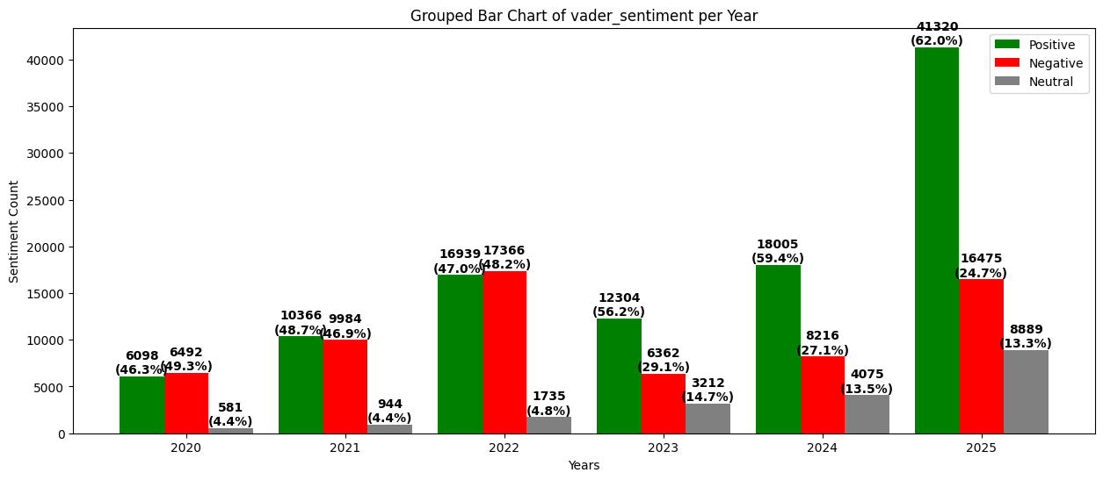
Figure 1: Grouped Bar Chart of vader sentiment per year
Figure 1 shows the annual distribution of VADER-assigned sentiment categories from 2020 to 2025. In 2020, positive (46.3%) and negative (49.3%) sentiment were approximately balanced, with neutral sentiment remaining low. In 2021, the overall volume increased while sentiment proportions remained similar. The highest volumes occurred in 2022, with increases in both positive and negative classifications. From 2023 to 2024, positive sentiment became dominant, peaking at 59.4%. By 2025, the distribution shifted back toward a pattern similar to that observed in 2020.

3.1.2 Text Blob Sentiment Trends (2020-2025)
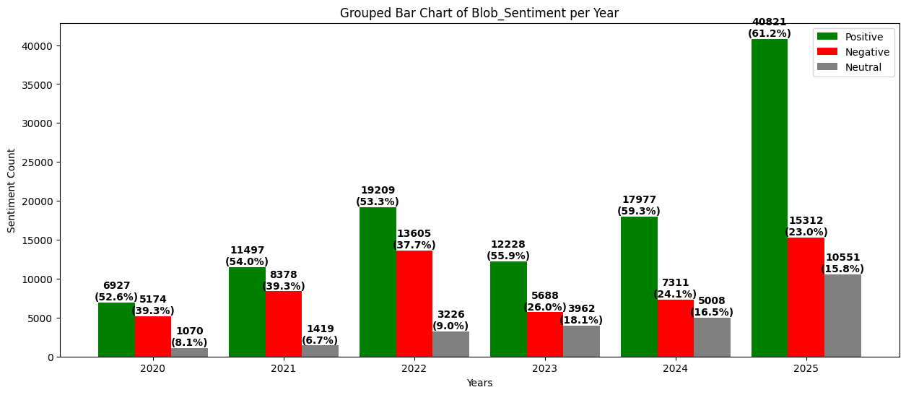
Figure 2: Grouped Bar Chart of Text Blob sentiment per year
Figure 2 presents the annual sentiment distributions produced by TextBlob from 2020 to 2025. Positive sentiment dominated throughout, increasing from 6,927 posts (52.6%) in 2020 to 40,821 posts (61.2%) in 2025. Negative sentiment ranged between 23% and 39%, while neutral sentiment, though consistently lower, increased gradually and peaked at 18.1% in 2023. Overall sentiment volume expanded over the period, particularly in 2025, which recorded increases across all categories. Across the six years, TextBlob produced a consistently positive-leaning distribution with year-to-year variation in negative and neutral classifications.

3.1.3 Transformer Sentiment Trends (2020-2025)
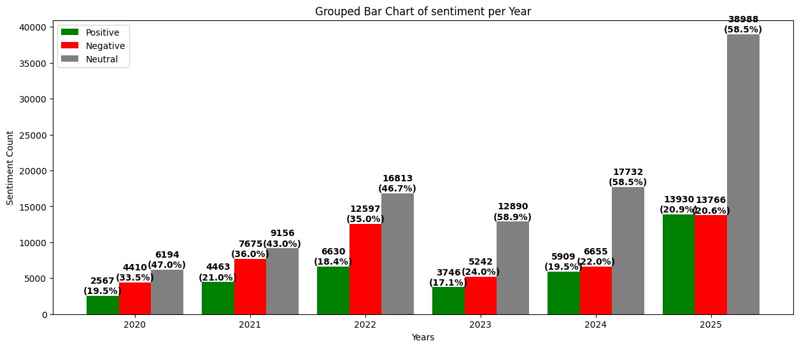
Figure 3: Grouped Bar Chart of Transformer-based sentiment per year
Figure 3 presents the annual sentiment distributions produced by the transformer-based classifier from 2020 to 2025. Across all years, a large proportion of posts were assigned to the neutral category. Neutral sentiment increased from 47.0% in 2020 to 58.5% in both 2024 and 2025. Positive sentiment remained lower, ranging between 17% and 21%, while negative sentiment varied from 21% to 36%. The highest overall volumes occurred in 2025, with 38,988 neutral posts, 13,930 positive posts and 13,766 negative posts. The transformer classifier produced a neutral-dominant sentiment distribution throughout the period.

3.1.4 Average Confidence Levels of Sentiment Models (2020-2025)
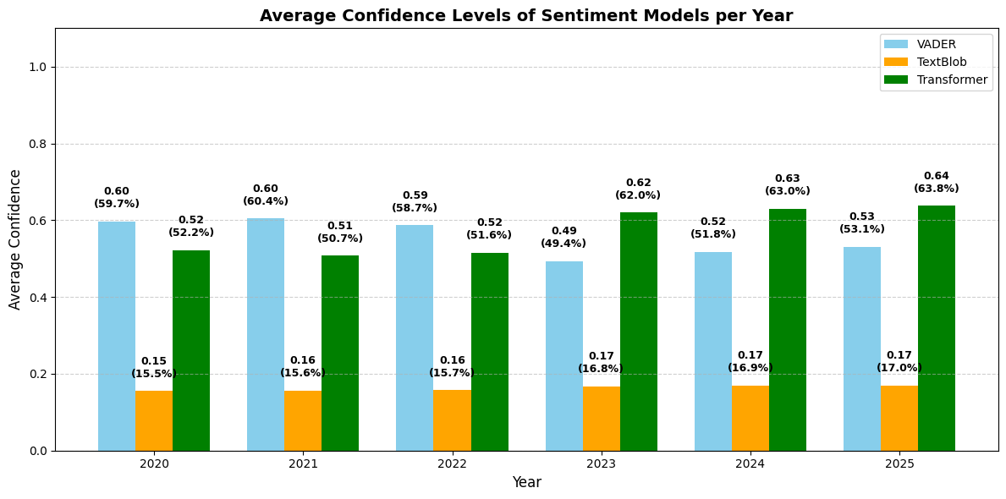
Figure 4: Average Confidence Levels of Sentiment Models
Figure 4 presents the average confidence scores of VADER, TextBlob and the transformer-based classifier from 2020 to 2025. Here, a confidence score reflects how certain a model is in its predicted sentiment label. VADER showed moderately high and stable values (0.49-0.60), peaking in 2021, declining in 2023 and rising again by 2025. TextBlob recorded the lowest scores (0.15-0.17) with minimal variation. The transformer-based classifier displayed higher and more variable confidence levels, increasing from 0.52 in 2020 to 0.64 in 2025. Overall, the three models exhibited distinct confidence ranges and temporal patterns.

3.1.5 Inter-Model Agreement (Cohen’s Kappa, 2020-2025)
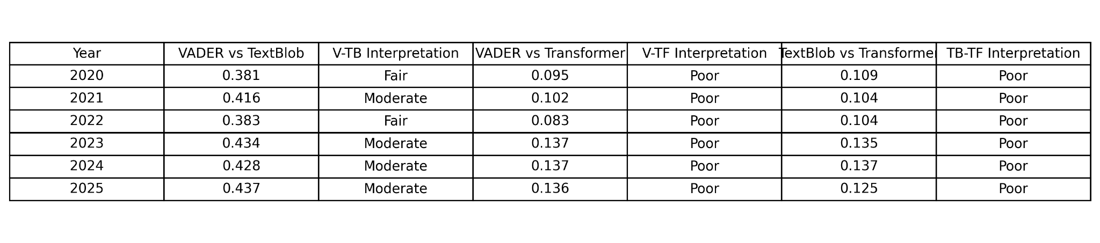Table 6: Inter-Model Agreement (Cohen’s Kappa, 2020-2025)
Table 6 presents an inter-model agreement between VADER, TextBlob and the transformer-based classifier using Cohen’s kappa. VADER and TextBlob exhibited the highest agreement, with kappa values ranging from 0.381 to 0.437, corresponding to fair to moderate agreement. In contrast, agreement between VADER and the transformer remained low (0.083-0.137), while similarly low values were observed between TextBlob and the transformer (0.104-0.137), all within the poor agreement range. Overall, agreement was higher between the two lexicon-based models than between either lexicon-based model and the transformer classifier.

3.2 Machine Learning Classification Results (2020-2025)

3.2.1 Naive Bayes Trends (2020-2025)
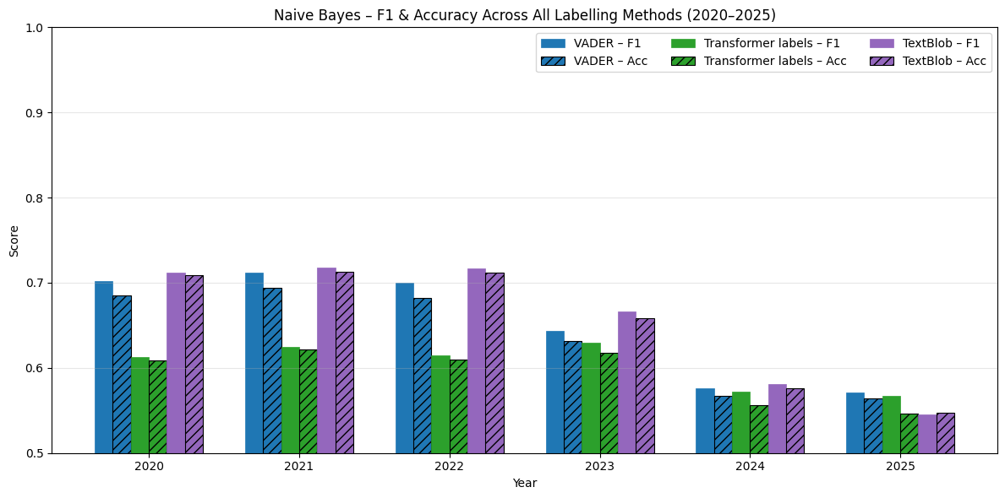Figure 5: Naive Bayes Trends (2020-2025)
The Naive Bayes classifier shows a steady decline in performance across all labelling methods between 2020 and 2025. Models trained using VADER and TextBlob labels achieved higher performance in earlier years, with F1-scores of approximately 0.70-0.72 between 2020 and 2022, before declining to around 0.57 by 2025. Accuracy followed a similar downward trend. In contrast, models trained with transformer-based labels consistently recorded lower performance, with F1-scores decreasing from approximately 0.61-0.63 to around 0.55 over the same period.

3.2.2 SVM Trends (2020-2025)
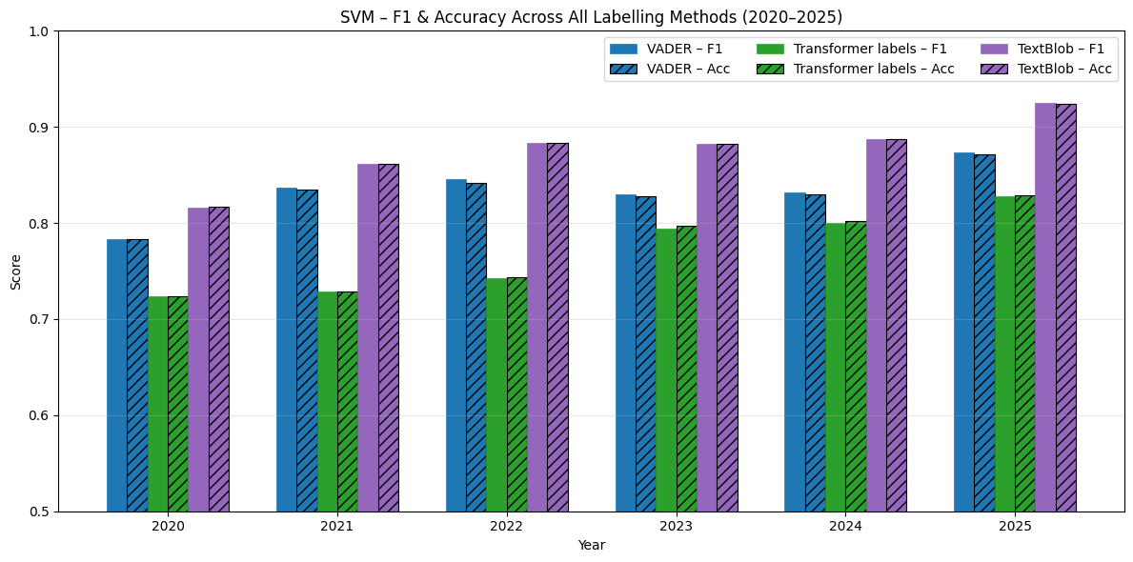Figure 6: SVM Trends (2020-2025)
The SVM classifier shows consistently improving performance across all labelling methods from 2020 to 2025. When trained using VADER labels, F1-scores increase from approximately 0.78 in 2020 to around 0.87 by 2025, with accuracy following a similar trend. TextBlob-labelled SVM models achieve the highest performance, rising from about 0.82 in 2020 to over 0.92 in 2025. Models trained using transformer-based labels start at lower F1-scores but improve steadily, reaching approximately 0.83 by 2025.

3.2.3 CNN Trends (2020-2025)
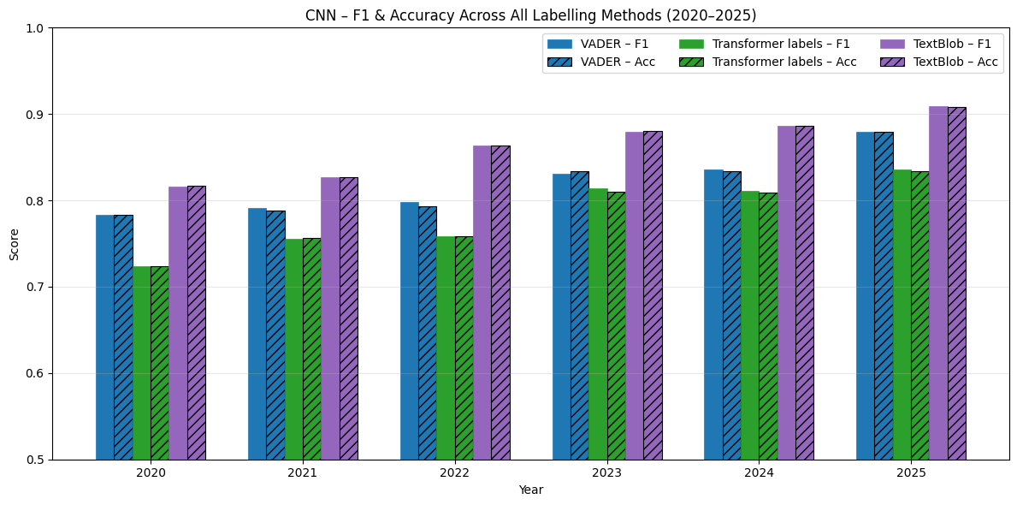Figure 7: CNN Trends (2020-2025)
The CNN classifier shows consistently strong and steadily improving performance across all labelling methods from 2020 to 2025. Models trained using VADER labels increase from an F1-score of approximately 0.78 in 2020 to around 0.88 in 2025. TextBlob-labelled CNN models achieve higher performance, rising from about 0.82 to over 0.90 during the same period. Models trained with transformer-based labels begin at lower F1-scores (approximately 0.72 to 0.73) but improve steadily, reaching around 0.84 by 2025.

3.2.4 Transformer(Bert) Trends (2020-2025)
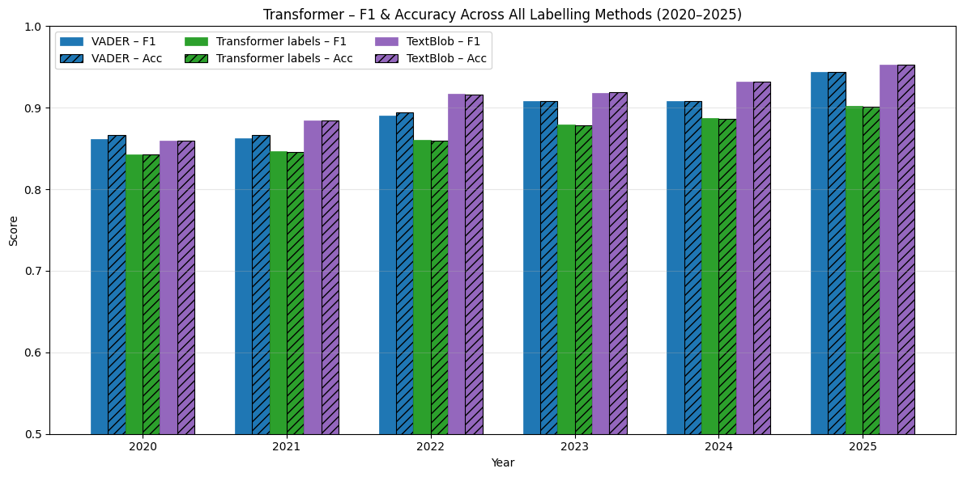
Figure 8: Transformer-BertTrends (2020-2025)
The Transformer-based classifier shows consistently high performance across all labelling methods from 2020 to 2025. When trained using VADER labels, F1-scores increase from approximately 0.86 in 2020 to around 0.94 by 2025. Models trained with TextBlob labels show a similar pattern, rising from about 0.86 to over 0.95 across the same period. Models trained using transformer-derived labels also improve steadily, increasing from approximately 0.84 in 2020 to around 0.91 by 2025.

3.2.5 Best Model Vs Best Labelling (Sentiment) (2020-2025)
Across all years from 2020 to 2025, the Transformer-based classifier consistently achieved the highest F1-scores, indicating superior performance relative to other modelling approaches. While optimal labelling strategies varied over time with VADER labels performing best in 2020 and TextBlob labels from 2021 onwards. The Transformer model remained the strongest classifier throughout the study period. The steady increase in F1-scores for both the best-performing model and labelling strategy suggests improvements in both model learning and label quality over time. Collectively, these findings indicate that combining transformer-based architectures with lexicon-derived sentiment labels yields the most robust sentiment classification performance for Reddit-based discourse.
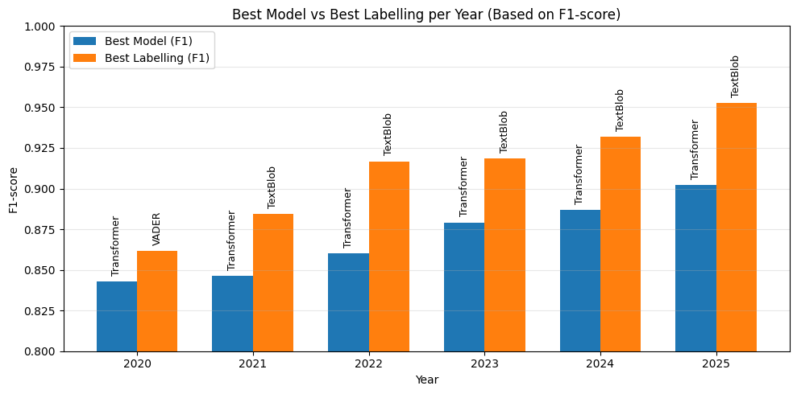Figure 9: Best Model VS Best Labelling per year Based on f1 Score (2020-2025)

3.3 Topic Modelling Trend Across Years (2020-2025)

3.3.1 LDA (Latent Dirichlet Allocation) Trend across Years (2020-2025)
Year | Topic | Number of Topics
2020 | Jobs, Work & Pay (Neg: 1,446; Pos: 1,122)  Other topics:  • General Opinions & Daily Experiences (Neg: 1,156; Pos: 614)  • Personal Thoughts & Judgements (Neg: 1,166; Pos: 593)  • UK & EU Politics (Neg: 642; Pos: 238) | 4
2021 | Work-Related Feelings & Stress (Neg: 3,340; Pos: 2,061)  Other topics:  • Jobs, Pay & Working Hours (Neg: 2,512; Pos: 1,790)  • General Frustration & Unreasonable Situations (Neg: 1,146; Pos: 380)  • UK Politics (Neg: 677; Pos: 232) | 4
2022 | Public Frustration, Complaints & Unreasonable Situations (Neg: 5,355; Pos: 2,637)  Other topics:  • Daily Work Life, Pay & Working Hours (Neg: 5,157; Pos: 3,281)  • UK Government, Boris Johnson & Political Resignations (Neg: 2,085; Pos: 712) | 3
2023 | General Opinions on Daily Life & Work (Neg: 2,946; Pos: 1,691)  Other topics:  • Needs, Pay, Jobs & Life Priorities (Neg: 2,183; Pos: 1,692)  • Moderation, Rules & Subreddit Administration (Neg: 113; Pos: 363) | 3
2024 | General Reflections on Work & Daily Life (Neg: 2,957; Pos: 1,760)  Other topics:  • Companies, Job Roles, Pay & Career Experience (Neg: 1,695; Pos: 1,241)  • Managers, Workplace Advice & Daily Job Issues (Neg: 1,995; Pos: 1,913)  • Moderation, Rules & Platform Administration (Neg: 8; Pos: 995) | 4
2025 | General Life & Work Satisfaction (Neg: 3,750; Pos: 3,298)  Other topics:  • Jobs, Roles & Career Decisions (Neg: 3,494; Pos: 3,539)  • Health Issues & Asking for Help (Neg: 1,066; Pos: 1,162)  • Salary, Pay & Cost of Living (Neg: 1,340; Pos: 596)  • Office Work, Managers & Working Hours (Neg: 1,745; Pos: 1,364)  • Daily Life, Food & Home Activities (Neg: 1,405; Pos: 772)  • Transport, Driving & Daily Payments (Neg: 869; Pos: 473)  • Reddit Advice, Jokes & Rule-Based Questions (Neg: 13; Pos: 8)  • Reddit Moderation & Job Megathreads (Neg: 2; Pos: 2,686)  • Government, Rules & Legal Requirements (Neg: 82; Pos: 32) | 10
Table 7: Dominant LDA Topic per Year (2020-2025)
This table summarises the LDA topic modelling results for each year, presenting the dominant topic, the total number of topics identified and the associated positive and negative document counts for both dominant and supporting themes. The table reports annual variation in topic counts and the distribution of employment-related themes across the study period.

3.3.2 Bertopic Trend across Years (2020-2025)
Year | Topic | Number of Topics
2020 | Top 5 most negative topics:  • COVID-19 & Public Health Crisis (Neg: 245; Pos: 202)  • NHS Pay & Healthcare Workforce Crisis (Neg: 217; Pos: 121)  • Unemployment & Job Market Struggles (Neg: 208; Pos: 190)  • Housing Costs & Cost of Living Crisis (Neg: 150; Pos: 105)  • Topic 12 (Neg: 129; Pos: 65) | 41
2021 | Top 5 most negative topics:  • NHS, Doctors & Healthcare Pay Crisis (Neg: 428; Pos: 208)  • Workplace Management & Job Conditions (Neg: 334; Pos: 216)  • Job Search, Interviews & Rejection (Neg: 289; Pos: 231)  • Flexible Working & Office Life (Neg: 222; Pos: 175)  • NHS Staff & Hospital Pressures (Neg: 217; Pos: 180) | 58
2022 | Top 5 most negative topics:  • NHS Staff, Nurses & Doctors Pay Crisis (Neg: 615; Pos: 411)  • UK Politics, Government & Policy Debate (Neg: 535; Pos: 263)  • Workplace Stress & Burnout (Neg: 513; Pos: 328)  • Job Security, Layoffs & Redundancy (Neg: 355; Pos: 198)  • Careers, Degrees & University-to-Job Pathways (Neg: 270; Pos: 313) | 91
2023 | Top 5 most negative topics:  • UK Government, NHS & National Policy (Neg: 394; Pos: 148)  • Jobs, Careers & University Qualifications (Neg: 368; Pos: 299)  • Driving, Cars & Road Incidents (Neg: 363; Pos: 325)  • Managers, HR & Workplace Disputes (Neg: 226; Pos: 127)  • Films, Music & Entertainment Media (Neg: 160; Pos: 59) | 66
2024 | Top 5 most negative topics:  • UK Politics, Labour, Government & Tax Policy (Neg: 2,850; Pos: 2,307)  • Jobs, Experience, Careers & Employability (Neg: 511; Pos: 238)  • UK Cities, London & Places to Live (Neg: 212; Pos: 112)  • Managers, Teams & Workplace Relationships (Neg: 166; Pos: 116)  • Life, Friendships & Personal Reflection (Neg: 135; Pos: 91) | 52
2025 | • Sleep, Nights & Daily Routines (Neg: 390; Pos: 330)  • Mental Health, Sickness & Workplace Stress (Neg: 176; Pos: 329)  • Minimum Wage & Salary Debates (Neg: 166; Pos: 74)  • Congratulations, Support & Positive Reactions (Neg: 165; Pos: 402)  • Topic 15 (Neg: 153; Pos: 97)  • Daily Life, Food & Home Activities (Neg: 1,405; Pos: 772) | 176
Table 8: Dominant Bertopic Topic per Year (2020-2025)
The BERTopic analysis identifies variation in both the number of topics and the dominant negative themes across the study period. The number of topics increases from 41 in 2020 to 176 in 2025. In 2020 and 2021, dominant negative topics relate primarily to public health, healthcare pay, workplace management and unemployment. In 2022, negative themes include healthcare pay disputes, workplace stress and job security. In 2023 and 2024, political and institutional topics feature more prominently alongside employment-related concerns. By 2025, dominant negative topics include daily routines, mental health and wage-related issues.

3.4 Thematic Analysis Trend Across Years (2020-2025)
Year | Dominant Theme (LDA) | Dominant Theme (Bertopic)
2020 | Employment & Pay Conditions | Public Health, Healthcare Workforce & Employment Uncertainty
2021 | Workplace Stress & Working Conditions | Healthcare Pay Disputes, Workplace Management & Job Insecurity
2022 | Public Frustration & Work-Related Dissatisfaction | Healthcare Crisis, Workplace Stress & Job Security
2023 | General Work & Life Reflections | Government Policy, Public Institutions & Employment
2024 | Work, Career & Workplace Reflection | Political Discontent, Employment & Workplace Relationships
2025 | Life & Work Satisfaction | Daily Routines, Mental Health & Wage-Related Concerns
Table 9: Thematic Analysis Topic per Year (2020-2025)
A comparison of LDA and BERTopic demonstrates both thematic consistency and methodological complementarity across the study period. In 2020-2021, both models emphasise employment-related concerns, with LDA capturing broad themes around jobs and pay, while BERTopic identifies more specific pressures related to healthcare, job insecurity and management. In 2022, both approaches reflect heightened dissatisfaction, though at different levels of granularity. From 2023 onwards, thematic focus shifts towards broader institutional and work-life reflection, with political and wellbeing-related concerns becoming more prominent. By 2025, both models highlight a transition towards mental health, daily routines and wage-related issues.

3.5 Temporal Analysis Trend Across Years (2020-2025)
Temporal analysis indicates clear shifts in dominant discussion themes over the study period. In 2020-2021, discourse is dominated by employment-related concerns, public health pressures and workplace stress, which will intensify in 2022 alongside public sector and job security issues. From 2023 onwards, attention increasingly shifts towards institutional and political concerns, while employment-related discussion persists. By 2024-2025, wellbeing, mental health and daily routines emerge as prominent themes, indicating a movement from crisis-driven discourse towards broader reflections on everyday working life.

4.0 DISCUSSION
This study examined how UK Reddit users expressed job dissatisfaction between 2020 and 2025 and showed that analytic outcomes vary substantially depending on the sentiment analysis, classification and topic-modelling methods used. The findings confirm that methodological choices strongly shape interpretations of online labour discourse, supporting arguments that multi-model triangulation is essential for analysing social-media text (Egger & Yu, 2022). At the same time, the contrasts across tools highlight the limitations of relying on a single modelling technique, as each encodes different assumptions about language and emotional expression.
Clear differences were seen in sentiment-labelling approaches. Lexicon-based tools such as VADER and TextBlob consistently generated more positive-skewed outputs, reflecting their known difficulty detecting irony, subtle frustration and contextual cues (Saha et al., 2023; Rana, 2025). By contrast, transformer-based classifiers assigned a much larger share of posts to the neutral category, aligning with research showing that contextual models handle ambiguity and mixed sentiment more effectively (Pham et al., 2025). In the context of job dissatisfaction, this suggests that workers often express frustration indirectly, which lexicon tools may misidentify as neutral or positive. Overall, these contrasts illustrate how sentiment tools measure negativity in fundamentally different ways.
Sentiment trajectories also aligned with major socio-economic developments. The balance of positive and negative sentiment in 2020 reflects early COVID-19 uncertainty. Apparent rises in positivity during 2022–2024 did not correspond with improved job quality; instead, they occurred during a period of inflation, wage stagnation and rising workplace stress. With real wage growth at only 0.5% in 2025, most workers experienced declining purchasing power. Combined with cost-of-living pressures and widespread burnout, especially in the NHS, increases in positive sentiment may reflect adaptation or lowered expectations rather than genuine improvement. Importantly, these patterns are highly model-dependent and temporal trends may partly reflect methodological bias rather than real shifts in worker attitudes.
Supervised classification results show increasing discourse complexity over time. Naive Bayes performance declined as language became more context-dependent (Ogaga & Olalere, 2023), while SVM, CNN and especially the transformer-based classifier achieved more stable F1-scores (Bayat & Işık, 2023). This reflects wider findings that transformers outperform classical models such as Naive Bayes and SVM on real-world text (Davoodi & Mezei, 2022). Models trained on VADER or TextBlob labels sometimes performed better than those using transformer labels, indicating that simpler lexicon-based annotations can create cleaner training signals. This highlights that supervised models inherit the limitations of their labelling source.
Topic-modelling results provided additional insight into shifting concerns. LDA generated only a few broad topics per year, as perplexity optimization favoured stable themes such as pay, stress and general reflections on work. BERTopic, however, produced many more fine-grained topics (41 in 2020 rising to 176 in 2025), capturing evolving concerns such as COVID-19 and NHS pressures, political dissatisfaction and, by 2025, mental health, routine work and wage stagnation. These differences align with evidence that LDA yields coarse themes while BERTopic identifies more nuanced subtopics (Egger & Yu, 2022; Liu, 2024). The divergence across models also highlights the interpretive challenges of comparing topic outputs generated under different assumptions.
Overall, the findings show that job dissatisfaction shifted from acute pandemic-related stress to a more chronic condition driven by economic pressures and declining well-being. Methodologically, the study demonstrates both the value and the limits of combining lexicon-based and transformer-based sentiment tools with classical and embedding-based topic models. Triangulation improves interpretive robustness, yet analytic outcomes remain shaped by model biases, annotation choices and sensitivity to design decisions.
These methodological contrasts suggest several directions for future work. Researchers should compare sentiment and topic-modelling tools more systematically in informal online contexts, explore hybrid sentiment methods to reduce misclassification of subtle dissatisfaction and apply consistent modelling frameworks across longer periods to distinguish true attitudinal change from methodological artefacts. Cross-platform comparisons and evaluations of annotation choices would further clarify how model biases shape interpretations of labour discourse.

5.0 CONCLUSION
This study examined how job dissatisfaction was expressed by UK Reddit users between 2020 and 2025 and showed that interpretations of online labour discourse are strongly influenced by methodological choices. Using both lexicon-based and transformer-based sentiment analysis alongside classical and embedding-based topic modelling, the study demonstrates the value of multimethod approaches for analysing informal online narratives.
The findings indicate that job dissatisfaction in the UK has not declined but evolved. During 2020-2022, discourse reflected acute pressures linked to COVID-19, NHS strain, job insecurity and burnout. From 2023 onwards, dissatisfaction increasingly centred on political tensions, institutional frustrations and work-life balance challenges. By 2025, concerns had become embedded in everyday experiences, particularly around mental health, wage stagnation and rising living costs, consistent with wider labour market evidence.
Methodologically, the study showed that lexicon-based tools tend to overestimate positivity, while transformer-based models capture more nuanced and neutral sentiment. Supervised classification results likewise favoured contextual transformer models and BERTopic identified more fine-grained and evolving issues than LDA, underscoring how model design shapes analytic outcomes.
Overall, job dissatisfaction appears persistent and multifaceted and robust analysis requires combining complementary NLP methods to capture both high-level trends and subtle shifts in public discourse.

REFERENCES
CIPD (2024) Good Work Index 2024: Survey Report. Available at: https://www.cipd.org/globalassets/media/knowledge/knowledge-hub/reports/2024-pdfs/8625-good-work-index-2024-survey-report-1-web.pdf
Office for National Statistics. (2022). Job quality in the UK: 2021. https://www.ons.gov.uk/releases/jobqualityintheuk2021
UK Parliament (2022) The impact of remote and hybrid working on workers and organisations (POSTbrief 49). Available at: https://researchbriefings.files.parliament.uk/documents/POST-PB-0049/POST-PB-0049.pdf
del Rio-Chanona, R.M., Hermida-Carrillo, A., Sepahpour-Fard, M., Sun, L., Topinkova, R. and Nedelkoska, L., 2023. Mental health concerns precede quits: shifts in the work discourse during the Covid-19 pandemic and great resignation. EPJ Data Science, 12(1), p.49.
Hoque Tania, M., Hossain, M.R., Jahanara, N., Andreev, I. and Clifton, D.A., 2022. Thinking aloud or screaming inside: Exploratory study of sentiment around work. JMIR Formative Research, 6(9), p.e30113.
Hutto, C. and Gilbert, E., 2014, May. Vader: A parsimonious rule-based model for sentiment analysis of social media text. In Proceedings of the international AAAI conference on web and social media (Vol. 8, No. 1, pp. 216-225).
Devlin, J., Chang, M.W., Lee, K. and Toutanova, K., 2019, June. Bert: Pre-training of deep bidirectional transformers for language understanding. In Proceedings of the 2019 conference of the North American chapter of the association for computational linguistics: human language technologies, volume 1 (long and short papers) (pp. 4171-4186).
Blei, D.M., Ng, A.Y. and Jordan, M.I., 2003. Latent dirichlet allocation. Journal of machine Learning research, 3(Jan), pp.993-1022.
Grootendorst, M., 2022. BERTopic: Neural topic modeling with a class-based TF-IDF procedure. arXiv preprint arXiv:2203.05794.
Eye.eu (n.d.) Reddit Archive - Historical Reddit Data Access Platform. Available at: https://eye.eu/
PRAW (n.d.) The Python Reddit API Wrapper. Available at: https://praw.readthedocs.io/
Curiskis, S.A., Drake, B., Osborn, T.R. and Kennedy, P.J., 2020. An evaluation of document clustering and topic modelling in two online social networks: Twitter and Reddit. Information Processing & Management, 57(2), p.102034.
Melton, C.A., Olusanya, O.A., Ammar, N. and Shaban-Nejad, A., 2021. Public sentiment analysis and topic modeling regarding COVID-19 vaccines on the Reddit social media platform: A call to action for strengthening vaccine confidence. Journal of Infection and Public Health, 14(10), pp.1505-1512.
Clark, A.E., 2005. Your money or your life: Changing job quality in OECD countries. British Journal of Industrial Relations, 43(3), pp.377-400.
Garg, R., Kapadia, Y. and Sengupta, S., 2021. Using the lenses of emotion and support to understand unemployment discourse on Reddit. Proceedings of the ACM on Human-Computer Interaction, 5(CSCW1), pp.1-24.
Egger, R. and Yu, J., 2022. A topic modeling comparison between lda, nmf, top2vec, and bertopic to demystify twitter posts. Frontiers in sociology, 7, p.886498.
Spector, P.E., 1997. Job satisfaction: Application, assessment, causes, and consequences (Vol. 3). Sage.
Weninger, T., Zhu, X.A. and Han, J., 2013, August. An exploration of discussion threads in social news sites: A case study of the reddit community. In Proceedings of the 2013 IEEE/ACM international conference on advances in social networks analysis and mining (pp. 579-583).
Devlin, J., Chang, M.W., Lee, K. and Toutanova, K., 2019, June. Bert: Pre-training of deep bidirectional transformers for language understanding. In Proceedings of the 2019 conference of the North American chapter of the association for computational linguistics: human language technologies, volume 1 (long and short papers) (pp. 4171-4186).
Spacesedan, n.d. Reddit Sentiment Analysis Longformer. Available at: https://huggingface.co/spacesedan/reddit-sentiment-analysis-longformer
Loria, S., 2018. TextBlob: Simplified Text Processing. Available at: https://textblob.readthedocs.io/.
Florisson, R., 2024. The UK insecure work index 2024. Work Foundation: London, UK.
Burke, H., 2023. Living and working in Europe 2022. Eurofound.
Zhao, W.X., Jiang, J., Weng, J., He, J., Lim, E.P., Yan, H. and Li, X., 2011, April. Comparing twitter and traditional media using topic models. In European conference on information retrieval (pp. 338-349). Berlin, Heidelberg: Springer Berlin Heidelberg.
Röder, M., Both, A. and Hinneburg, A., 2015, February. Exploring the space of topic coherence measures. In Proceedings of the eighth ACM international conference on Web search and data mining (pp. 399-408).
Pham, K., Kathala, K.C.R. and Palakurthi, S., 2025. Reddit Sentiment Analysis on the Impact of AI Using VADER, TextBlob, and BERT. Procedia Computer Science, 258, pp.886-892.
Rana, N., 2025. Lexicon vs. Transformer-Based Models for Sentiment Analysis. Medium. Available at: https://rananeha.medium.com/lexicon-vs-transformer-based-models-for-sentiment-analysis-56a80c8f4b10
Saha, S., Showrov, M.I.H., Rahman, M.M. and Majumder, M.Z.H., 2022, September. Vader vs. bert: A comparative performance analysis for sentiment on coronavirus outbreak. In International Conference on Machine Intelligence and Emerging Technologies (pp. 371-385). Cham: Springer Nature Switzerland.
Office for National Statistics (ONS), 2025. Average weekly earnings in Great Britain: November 2025. Available at: https://www.ons.gov.uk/employmentandlabourmarket/peopleinwork/employmentandemployeetypes/bulletins/averageweeklyearningsingreatbritain/november2025
Ogaga, D. and Olalere, A., 2023. Evaluation and Comparison of SVM, Deep Learning, and Naïve Bayes Performances for Natural Language Processing Text Classification Task.
Bayat, S. and Işık, G., 2023. Evaluating the effectiveness of different machine learning approaches for sentiment classification. Journal of the Institute of Science and Technology, 13(3), pp.1496-1510.
Liu, Y., 2024. Comparison of LDA and BERTopic in News Topic Modeling: A Case Study of The New York Times’ Reports on China. Pacific International Journal, 7(3), pp.47-51.
Davoodi, L. and Mezei, J., 2022, June. A comparative study of machine learning models for sentiment analysis: Customer reviews of e-commerce platforms. In Bled eConference: Digital Restructuring and Human (Re) Action.
r/antiwork: https://www.reddit.com/r/antiwork/
r/UKJobs: https://www.reddit.com/r/UKJobs/
r/fireUK: https://www.reddit.com/r/FIREUK/
r/AskUK: https://www.reddit.com/r/AskUK/
r/CasualUK: https://www.reddit.com/r/CasualUK/
r/unitedkingdom: https://www.reddit.com/r/unitedkingdom/
r/WorkReform: https://www.reddit.com/r/WorkReform/
r/careerguidance: https://www.reddit.com/r/careerguidance/
r/britishproblems: https://www.reddit.com/r/britishproblems/
r/recruitinghell: https://www.reddit.com/r/recruitinghell/

